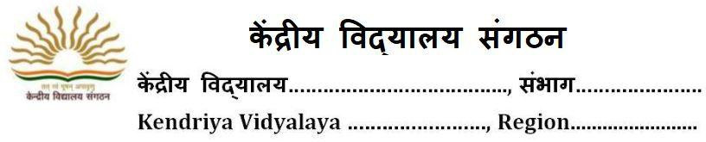
OPTION FORM FOR KV STUDENTS FOR ADMISSION TO CLASS XI (2021-22)

Reg No Date of Reg.
Paste your
Latest Photograph

STREAM CHOICE:
- Science
- Commerce
- Humanities

- Name of applicant:
- School last Attended:

- (a) Father’s Name:
(b) Occupation:
( c) Basic Pay:
Mother’s Name Occupation: Basic Pay :

- Service Category of Parent as per KVS Admission guidelines

- Residential Address:

- Phone /Mobile No Email id

- Category of Applicant (Specify Gen./ SC/ST/OBC(NCL)):

(if SC/ST/OBC(NCL), attach self-attested photocopy of certificates)

- Result of class X (supported by photo copy of mark sheet) CBSE Roll No.

Subject | Marks | Subject | Marks
Hindi |  | Mathematics Standard
Sanskrit |  | Mathematics Basic
English |  | Science
Social Science |  | Total Marks with % | /500 | %

- Aggregate Marks in Science & Math

- Subject Opted Core Subject (1) English

Elective Subject (2) (3)

(4) (5)

- Whether participated in SGFI/KVS National /Regional Sports Meet/Scout/Guide/NCC (if yes, please attach attested photo copies of certificate and give details). Specify the level also

(All taken together Aggregate Marks will not be exceeded by 6%)
We hereby declare that the above information furnished is true to the best of our knowledge.

Date: Signature of Student Parent‘s Signature

Criteria for the admission to class XI in Kendriya Vidyalaya

KV STUDENTS
Admission in different Streams viz. Science, Commerce, Humanities of class XI in KVs for KV students will be based on cut-off Grade and percentage as under:-

SCIENCE STREAM -
A minimum of Aggregate 60%

COMMERCE STREAM-
A minimum of Aggregate 55%

HUMANITIES STREAM-
All students of KV if declared successful in class X exam.

NON KV STUDENT
If seats remain vacant in class XI even after admitting the children of KV/Neighboring KVs, then the admission to non-KV children may be granted on the same criteria (as stated above for KV students) in the sequence of categories of priority.

The following concessions will be allowed for admission for Class XI.
- The following concession will be granted to students for admission who participated in Games & Sports meet/Scouting & Guiding/NCC/Adventure activities at various levels. The certificate needed for this purpose can be of any of the preceding years.

S.No. | Sports & Games | NCC | Scouting/ Guiding | Adventure Activities for admission to Science/ Commerce stream | Concession of marks / Grade Points
a. | Participation at SGFI or equivalent  level. | ‘A’ certificate and participation in  Republic Day/PM Rally | Rashtrapati Puraskar award certificate | NIL | 6% in Aggregate
b. | Participation at KVS National/  State level | ‘A’ certificate and best Cadet in Distt/State  level | Rajya Puruskar award certificate with 07  proficiency badges. | NIL | 4% in Aggregate
c. | Participation at  KVS Regional/ District Level | ‘A’ certificate | Tritiya Sopan  certificate with 05 proficiency badges | Participation in at  least one 10-days adventure activity | 2% in Aggregate

- Students belonging to SC/ST/OBC/ Divyang (PH) would be given up-gradation in aggregate by 4% Marks for the purpose of admission to class XI.
NOTE: Maximum concession under Sports/Games/NCC / Scout / Guide/Adventure will not be exceeded 6% in Aggregate .In case of eligibility for more than one concession under different categories as mentioned at (Point 1) and (Point 2) above, only one concession having maximum advantage to the candidate will be allowed .

* The all above mentioned admission rules/criteria are as per KVS Admission Guidelines 2021- 22, these may be changed by KVS at any time and all these amendment issued by KVS in future (if any) will be automatically applied on this Vidyalaya.

NOTE: You can email all required documents along with this registration form to KV concern

